SYSTEMS ENGINEERING PLAN (SEP)

OUTLINE

Version 3.0

May 12, 2017

Office of the Deputy Assistant Secretary of Defense for   
Systems Engineering

Washington, D.C.

#### Expectation: Program Manager will prepare a SEP to manage the systems engineering activities in accordance with Department of Defense Instruction (DoDI) 5000.02, Operation of the Defense Acquisition System.

The following SEP Outline was prepared by the Office of the Deputy Assistant Secretary of Defense for Systems Engineering (DASD(SE)) for use by Department of Defense (DoD) acquisition programs. This outline indicates required content for DoD SEPs as well as guidance regarding appropriate details to include in each section.

Although this outline indicates required SEP content, the format is not prescribed. The Component may use this document as a template or establish a SEP template that includes the required content.

Please direct questions or comments to the Office of Primary Responsibility (OPR):

Deputy Assistant Secretary of Defense

Systems Engineering

Attention: SEP

3030 Defense Pentagon

3C167

Washington, DC. 20301-3030

E-mail: osd.sep@mail.mil

http://www.acq.osd.mil/se/

MANDATORY CONTENT FOR ALL  
SYSTEMS ENGINEERING PLANS

PROGRAM NAME – ACAT LEVEL___

SYSTEMS ENGINEERING PLAN

VERSION ___

SUPPORTING MILESTONE ___

AND

[APPROPRIATE PHASE NAME]

[DATE]

**\*\*\*\*\*\*\*\*\*\*\*\*\*\*\*\*\*\*\*\*\*\*\*\*\*\*\*\*\*\*\*\*\*\*\*\*\*\*\*\*\*\*\*\*\*\*\*\*\*\*\*\*\*\*\*\*\*\*\*\*\*\*\*\*\*\*\*\*\*\*\*\*\*\*\*\*\*\*\*\*\*\*\*\*\***

MILESTONE DECISION AUTHORITY (MDA) APPROVAL

|  |  |
| --- | --- |
| _______________________________________________  MDA Name  MDA Signature Block | ___________________________  Date |

(or designated SEP approval authority)

SUBMITTED BY

|  |  |  |  |
| --- | --- | --- | --- |
| __________________________  Name  Program Lead Systems Engineer | __________  Date | __________________________  Name  Program Manager | _________  Date |

concurrence

|  |  |  |  |
| --- | --- | --- | --- |
| __________________________  Name  Lead/Chief Systems Engineer  (System Center or Command) | __________  Date | __________________________  Name  Program Executive Officer or Equivalent | _________  Date |

component approval

|  |  |
| --- | --- |
| __________________________  Name  Title, Office  Component SEP Approval  Authority | __________  Date |

Contents

1. Introduction 7

2. Program Technical Requirements 8

2.1. Architectures and Interface Control 8

2.2. Technical Certifications 8

3. Engineering Resources and Management 10

3.1. Technical Schedule and Schedule Risk Analysis 10

3.1.1. Relationships with External Technical Organizations 12

3.1.2. Schedule Management 12

3.1.3. System of Systems Schedule 12

3.1.4. Schedule Risk Analysis 13

3.2. Technical Risk, Issue, and Opportunity Management 14

3.3. Technical Structure and Organization 17

3.3.1. Work Breakdown Structure 17

3.3.2. Government Program Office Organization 17

3.3.3. Program Office Technical Staffing Levels 19

3.3.4. Engineering Team Organization and Staffing 20

3.4. Technical Performance Measures and Metrics 24

4. Technical Activities and Products 29

4.1. Planned SE Activities for the Next Phase 29

4.2. Requirements Development and Change Process 30

4.3. Configuration and Change Management 32

4.4. Design Considerations 34

Appendix A – Acronyms 40

Appendix B – Item Unique Identification Implementation Plan 40

References 40

*Note:* All topics above are required by Section 139b of title 10 United States Code and DoDI 5000.02. Additional content is optional at the discretion of the Component.

Tables

Table 2.2‑1 Certification Requirements (mandatory) (sample) 8

Table 3.2‑1 Opportunity Register (if applicable) (sample) 17

Table 3.3‑1 Integrated Product Team Details (mandatory unless charters are submitted) (sample) 22

Table 3.4‑1 Technical Performance Measures and Metrics (mandatory) (sample) 25

Table 4.1‑1 Technical Review Details (mandatory) (sample) 30

Table 4.2‑1 Requirements Traceability Matrix (mandatory) (sample) 31

Table 4.4‑1 Design Considerations (mandatory) (sample) 35

Table 4.4‑2 CPI and Critical Components Countermeasure Summary (mandatory) (sample) 38

Table 4.4‑3 R&M Activity Planning and Timing (mandatory) (sample) 39

Figures

Figure 3.1‑1 System Technical Schedule as of [Date] (mandatory) (sample) 11

Figure 3.1‑2 System-of-Systems Schedule as of [Date] (mandatory) (sample) 13

Figure 3.2‑1 Risk Reporting Matrix as of [Date] (mandatory) (sample) 15

Figure 3.2‑2 Risk Burn-Down Plan as of [Date] (mandatory for high risks others optional) (sample) 16

Figure 3.3‑1 Program Office Organization as of [Date] (mandatory) (sample) 18

Figure 3.3‑2 Program Technical Staffing (mandatory) (sample) 19

Figure 3.3‑3 SEPM Budget (mandatory) (sample) 20

Figure 3.3‑4 IPT/WG Hierarchy (mandatory) (sample) 21

Figure 3.4‑1 Technical Performance Measure or Metric Graph (recommended) (sample) 26

Figure 3.4‑2 TPM Contingency Definitions 26

Figure 3.4‑3 Reliability Growth Curve (mandatory) (sample) 27

[Figure 4.2‑1 Requirements Decomposition/Specification Tree/Baselines (mandatory)   
(sample) 32](#_Toc480906442)

Figure 4.3‑1 Configuration Management Process (mandatory) (sample) 33

*Note:* Additional tables and figures may be included at the Component or Program Manager’s discretion.

# Introduction

* Who uses the Systems Engineering Plan (SEP)?
* What is the plan to align the Prime Contractor’s Systems Engineering Management Plan (SEMP) with the Program Management Office (PMO) SEP?
* Describe and provide reasoning for any tailoring of the SEP Outline.
* Summarize how the SEP is updated and the criteria for doing so, to include:
* Timing of SEP updates such as following a conducted technical review, prior to milestones or Development Request for Proposal (RFP) Release Decision Point, or as a result of systems engineering (SE) planning changes
* The SEP should be updated after contract award to reflect (1) the winning contractor(s)’ technical approach reflected in the SEMP and (2) details not available before contract award
* Updating authority
* Approval authorities for different types of updates.

#### Expectations: Program Manager will prepare a SEP to manage the systems engineering activities starting at Milestone A (DoDI 5000.02 (Change 2, Feb 2, 2017), Enclosure 3, para. 2.a., page 94). The SEP should be a “living” “go-to” technical planning document and the blueprint for the conduct, management, and control of the technical aspects of the government’s program from concept to disposal. SE planning should be kept current throughout the acquisition life cycle.

* + - * The SEP will support the Acquisition Strategy and will be consistent with other program documentation (DoDI 5000.02 (Change 2, Feb 2, 2017), Enclosure 3, para. 2.a., page 94).
      * The SEP is a planning and management tool, highly specific to the program and tailored to meet program needs.
      * The SEP defines the methods for implementing all system requirements having technical content, technical staffing, and technical management.
      * The Milestone Decision Authority (MDA)-approved SEP provides authority and empowers the Lead Systems Engineer (LSE)/Chief Engineer to execute the program’s technical planning.

# Program Technical Requirements

## Architectures and Interface Control

Describe the architecture products the program will develop. Explain how architecture products are related to requirements definition. (See Defense Acquisition Guidebook (DAG) CH 3–4.2.3, Architecture Design Process, for additional guidance: <https://shortcut.dau.mil/dag/CH03.04.02.03>.) Include as appropriate the following:

* List of the program’s planned suite of architecture products with status of each
* Architecture diagrams (e.g., physical, functional, and software (SW))
* For programs that include SW development, a Software Development Plan or associated link
* List and reference for all program Component-specific and joint mission threads (JMT).

#### Expectations: Architectures are generated to better describe and understand the system and how the subsystems join together, to include internal and external interfaces, to form the system. To ensure architectures are properly formulated, programs should analyze mission thread(s). Describe the program’s plans to develop architecture products to support requirements and specification development.

## Technical Certifications

Summarize in the table format (see Table 2.2-1) the system-level technical certifications obtained during program’s life cycle. (See DAG CH 3–2.6, Certifications, for additional guidance: <https://shortcut.dau.mil/dag/CH03.02.06>.)

Table 2.2‑1 Certification Requirements (mandatory) (sample)

| Certification | PMO Team/POC | Activities to Obtain Certification1 | Certification  Authority | Expected Certification Date |
| --- | --- | --- | --- | --- |
| Airworthiness | Airframe IPT |  |  | ?Q FY? |
| Joint Interoperability Test Command (JITC) | Systems Engineering Integration and Test (SEIT) | Operational test demonstrates the system:   * Is able to support military operations * Is able to be entered and managed on the network * Effectively exchanges information | JITC system interoperability test certification memorandum | ?Q FY? |
| Weapon System Explosives Safety Review Board (WSESRB) | SEIT | Complete action items.  Submit WSESRB package to board. |  | ?Q FY? |
| Transportability |  |  |  | ?Q FY? |
| Insensitive Munitions (IM) | Manufacturing Working Group | Reference Document: PEO IM Strategic Plan |  | ?Q FY? |
| Etc. |  |  |  | ?Q FY? |

1 *Note:* This entry should be specific, such as a specification compliance matrix; test, inspection, or analysis; or a combination. It can also reference a document such as the Test and Evaluation Master Plan (TEMP) for more information.

#### Expectations: Program includes the plans for required technical certification activities and timing in the program Integrated Master Plan (IMP) and the Integrated Master Schedule (IMS).

# Engineering Resources and Management

## Technical Schedule and Schedule Risk Analysis

* List scheduling/planning assumptions.
* Include a copy of the latest Integrated Master Plan (IMP)/Integrated Master Schedule (IMS).
* Discuss the relationship of the program’s IMP to the contractor(s) IMS, how they are linked/interfaced, and what the primary data elements are.
* Identify who or what team (e.g., Integrated Product Team/Working Group (IPT/WG)) is responsible for developing the IMP, when it is required, and whether it is a part of the RFP.
* Describe how identified technical risks are incorporated into the program’s IMP and IMS.
* If used, discuss how the program uses Earned Value Management (EVM) cost reporting to track/monitor the status of IMS execution and performance to plan.
* If EVM is not used, state how often and discuss how the IMS is tracked according to contract requirements.
* Provide a current technical schedule derived from the IMP/IMS (see Figure 3.1-1) for the acquisition phase the program is entering, such as:
* SE technical reviews and audits
* Technology on/off-ramps
* RFP release dates
* SW builds/releases
* Hardware (HW)/SW Integration phases
* Contract award (including bridge contracts)
* Testing events/phases
* System-level certifications
* Technology Readiness Assessments (TRAs)
* Manufacturing assessments
* Logistics/sustainment events
* Long-lead or advanced procurements
* Technology development efforts to include prototyping
* Production lot/phases
* Need dates for government-furnished equipment (GFE) deliveries

*Note:* Include an “as-of” date with time-sensitive figures. If figures are taken from another original source, note the source and year. Note the classification of the figure.

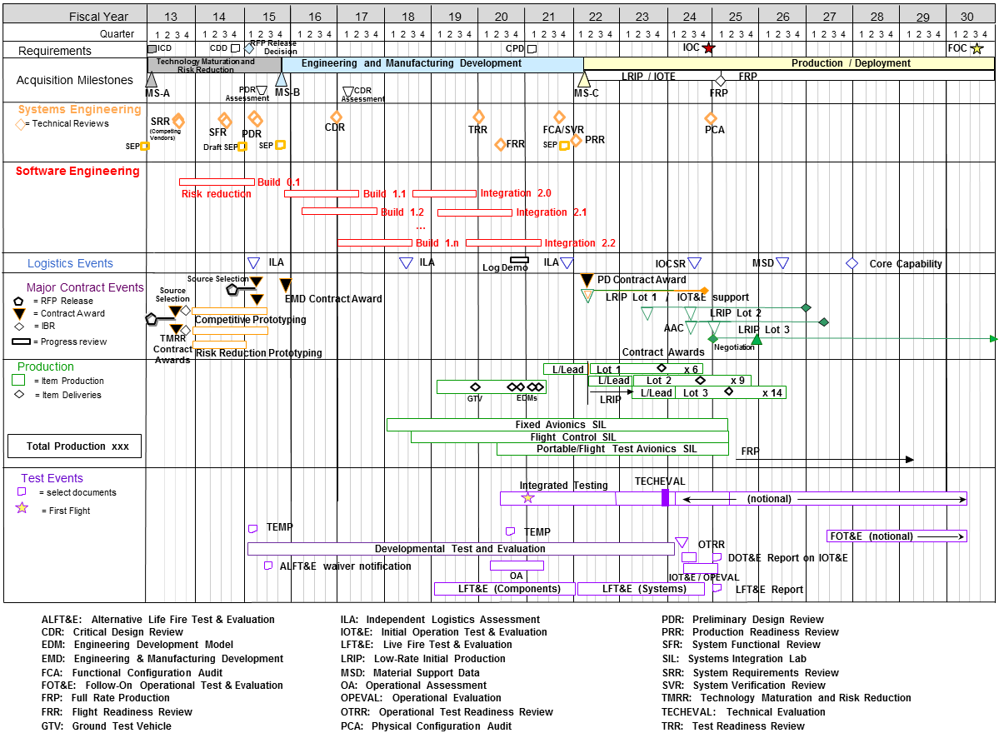

Source: Name Year [if applicable]. Classification: UNCLASSIFIED.

Figure 3.1‑1 System Technical Schedule as of [Date] (mandatory) (sample)

### Relationships with External Technical Organizations

Describe the external organization integration plan. Identify the organization responsible for coordinating SE and integration efforts associated with the family of systems/system of systems (FoS/SoS) and its authority to reallocate resources (funding and manpower). Describe methods used to document, facilitate, and manage interaction among SE team(s) and external-to-program government organizations (e.g., OUSD, FoS/SoS) on technical tasks, activities, and responsibilities (e.g., requirements, technical baselines, and technical reviews).

### Schedule Management

Summarize how FoS/SoS interfaces are managed, to include:

* Resolution of issues that cross Program Manager, PEO, and Component lines
* Interface Control Documents (ICDs) and any interface control WGs (ICWGs)
* “Triggers” that require a FoS/SoS member to inform the others if there is a cost, schedule, or performance deviation
* Description of who or what team (e.g., IPT/WG) is responsible for maintaining the alignment of the IMP and IMS across the interdependent programs
* Planned linkage between HW and SW upgrade programs within the FoS/SoS
* Any required government-furnished equipment/property/information (GFE/GFP/GFI) (e.g., test ranges, integration laboratories, and special equipment).

### System of Systems Schedule

Include an SoS schedule (mandatory, see Figure 3.1-2) that shows FoS/SoS dependencies such as alignment of technical reviews, major milestones, test phases, GFE/GFP/GFI, etc.

#### Expectations: Programs should

* + - * Manage the internal program schedule and synchronize it with external program schedules.
      * Identify external interfaces with dependencies clearly defined. This should include interface control specifications or documents, which should be confirmed early on and placed under strict configuration control. Compatibility with other interfacing systems and common architectures should be maintained throughout the development/design process.
      * Develop Memorandums of Agreement with interfacing organizations that include:
        + Tripwires and notification to FoS/SoS members of any significant (nominally > 10%) variance in cost, schedule, or performance
        + Mechanisms for FoS/SoS members to comment on proposed interface changes
        + Fast-track issue identification and resolution process.
      * Inform Component and OSD staffs so they better understand synchronizing funding and aligning priorities with external programs.

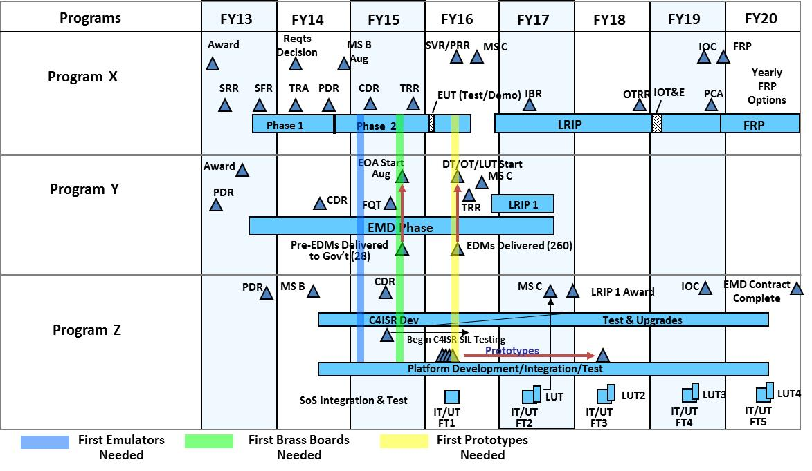

Source: Name Year if applicable. Classification: UNCLASSIFIED.

Figure 3.1‑2 System-of-Systems Schedule as of [Date] (mandatory) (sample)

(*Note:* Include an as-of date – time-sensitive figure.)

#### Expectations: Program should properly phase activities and key events (competitive and risk reduction prototyping, TRA, Preliminary Design Review (PDR), Critical Design Review (CDR), etc.) to ensure a strong basis for financial commitments. Program schedules are event driven and reflect adequate time for SE, integration, test, corrective actions, and contingencies. SEPs for approval should include a current schedule, no more than 3 months old.

### Schedule Risk Analysis

* Summarize the program’s planned schedule risk analysis (SRA) products. Describe how each product will help determine the level of risk associated with various tasks and the readiness for technical reviews, and therefore how each product will help inform acquisition decisions. Identify who will perform SRAs, methodologies used, and periodicity.
* Discuss how often Defense Contract Management Agency (DCMA) 14-point schedule health checks (Earned Value Management System (EVMS) Program Analysis Pamphlet (PAP) (DCMA-EA PAM 200.1) October 2012: <http://www.dcma.mil/LinkClick.aspx?fileticket=0CBjAarXWZA%3d&portalid=31>) are conducted on the IMS and how results are used to improve the IMS structure.
* Describe the impact of schedule constraints, dependencies, and actions taken or planned to mitigate schedule drivers.
* Describe the periodicity for identifying items on the critical path and identify risk mitigation activities to meet schedule objectives.

#### Expectation: Program regularly checks IMS health and conducts SRAs to inform program decisions.

## Technical Risk, Issue, and Opportunity Management

* **Risk, Issue and Opportunity Management (RIO) Process Diagrams**
* If a program has a RIO management document, then provide a link.
* **Otherwise, describe:**
* Roles, responsibilities, and authorities within the risk management process for:
  + - Reporting/identifying risks or issues
    - Criteria used to determine whether a “risk” submitted for consideration becomes a risk or not (typically, criteria for likelihood and consequence)
    - Adding/modifying risks
    - Changing likelihood and consequence of a risk
    - Closing/retiring a risk or issue.
* If Risk Review Boards or Risk Management Boards are part of the process, identify the chair and participants and state how often they meet.
* **Risk/Issue Management**
* Risk Tools – If program office and contractor(s) use different risk tools, how is the information transferred? *Note:* In general, the same tool should be used. If the contractor’s tool is acceptable, the government may opt to use it but must have direct, networked access to the tool.
* Technical Risk and Mitigation Planning – Summarize the key engineering, integration, reliability, manufacturing, technology, and unique SW risks and planned mitigation measures for each risk.
* Risk Reporting – Provide a risk reporting matrix (see Figure 3.2-1) or a list of the current system-level technical risks and issues with:
  + - As-of date
    - Risk rating
    - Risk statement and consequences, if realized
    - Mitigation activities, and expected closure date.





Source: Name Year if applicable. Classification: UNCLASSIFIED.

Figure 3.2‑1 Risk Reporting Matrix as of [Date] (mandatory) (sample)

(*Note:* Include an as-of date – time-sensitive figure.)

* **Risk Burn-Down**
* Describe the program’s use of risk burn-down plan to show how mitigation activities are implemented to control and retire risks. Also discuss how activities are linked to Technical Performance Measures (TPMs) and to the project schedule for critical tasks. For each high technical risk, provide the risk burn-down plan. (See figure 3.2-2 for a sample risk burn-down plan.)

#### Expectations: Program uses hierarchical boards to address risks and integrates risk systems with contractors. The approach to identify risks is both top-down and bottom-up. Risks related to technology maturation, internal and external integration, and each design consideration indicated in Table 4.4‑1 (page 35) are considered in risk identification. SEPs submitted for approval contain a current, updated Risk Reporting Matrix and associated Risk Burn-Down curves for high technical risks.



Source: Name Year if applicable. Classification: UNCLASSIFIED.

Figure 3.2‑2 Risk Burn-Down Plan as of [Date] (mandatory for high risks others optional) (sample)

(*Note:* Include an as-of date – time-sensitive figure.)

* **Opportunity Management** – Discuss the program’s opportunity management plans to create, identify, analyze, plan, implement, and track initiatives (including technology investment planning) that can yield improvements in the program’s cost, schedule, and/or performance baseline through reallocation of resources.
* If applicable, insert a chart or table that depicts the opportunities being pursued, and summarize the cost/benefit analysis and expected closure dates (see Table 3.2-1 for example).

Table 3.2‑1 Opportunity Register (if applicable) (sample)

|  |  |  |  |  |  |  |  |  |  |  |  |
| --- | --- | --- | --- | --- | --- | --- | --- | --- | --- | --- | --- |
| Opportunity | Likeli-hood | Cost to Implement | Return on Investment | | | | | Program Priority | Management Strategy | Owner | Expected Closure |
| Monetary | | | Schedule | Performance |
| RDT&E | Procurement | O&M |
| Opportunity 1: Procure Smith rotor blades instead of Jones rotor blades. | Mod | $3.2M |  |  | $4M | 3-month margin | 4% greater lift | #2 | Reevaluate; summarize the plan | Mr. Bill Moran | March 2017 |
| Opportunity 2: Summarize the opportunity activity. | Mod | $350K | $25K |  | $375K |  |  | #3 | Reject | Ms. Dana Turner | N/A |
| Opportunity 3: Summarize the opportunity activity. | High | $211K |  | $0.04M | $3.6M | 4 months less long-lead time needed |  | #1 | Summarize the plan to realize the opportunity | Ms. Kim Johnson | January 2017 |

Source: Name Year if applicable. Classification: UNCLASSIFIED.

## Technical Structure and Organization

### Work Breakdown Structure

If a Work Breakdown Structure (WBS) currently exists, then provide link. Otherwise, provide the following information:

* Summarize the relationship among the WBS, product structure, and schedule.
* Explain the traceability between the system’s technical requirements and the WBS.

### Government Program Office Organization

Provide the planned program office organization structure (i.e., wiring diagram to illustrate hierarchy and any positions that are not filled) with an as-of date, and include the following elements (see Figure 3.3-1):

* Organization to which the program office reports
* Program Manager
* Lead/Chief Systems Engineer (LSE/CSE)
* Functional Leads (e.g., test and evaluation (T&E), logistics, risk, production, reliability, SW).

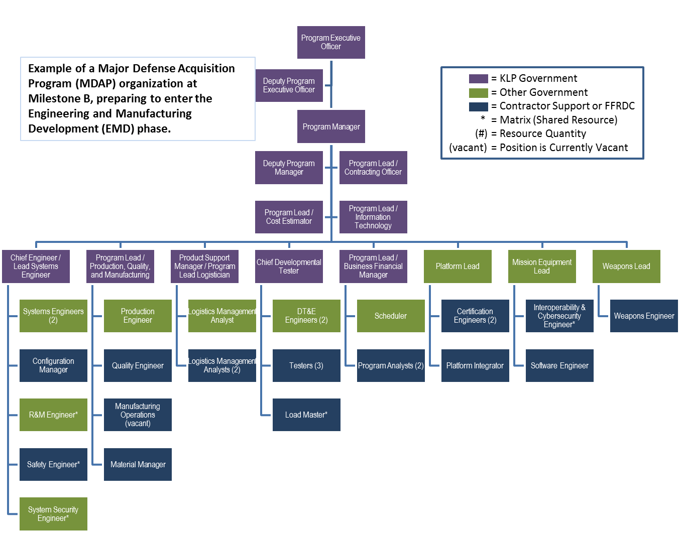

Source: Name Year if applicable. Classification: UNCLASSIFIED.

Figure 3.3‑1 Program Office Organization as of [Date] (mandatory) (sample)

(*Note:* Include an as-of date – time sensitive figure.)

### Program Office Technical Staffing Levels

Summarize the program’s technical staffing plan to include:

* Risks and increased demands on existing resources if staffing requirements are not met
* A figure (e.g., sand chart, see Figure 3.3-2) to show the number of required government program office full-time equivalent (FTE) positions (e.g., organic, matrix support, and contractor support) over time, by key program events (e.g., milestones and technical reviews)
* A figure to show the program’s budget for SE and program management (SEPM) over time as a percentage of total program budget (see Figure 3.3-3)
* Adequacy of SW development staffing resources.

#### Expectations: Program should use a workload analysis tool to determine the adequate level of staffing, appropriate skill mix, and required amount of experience to properly staff, manage, and execute successfully.

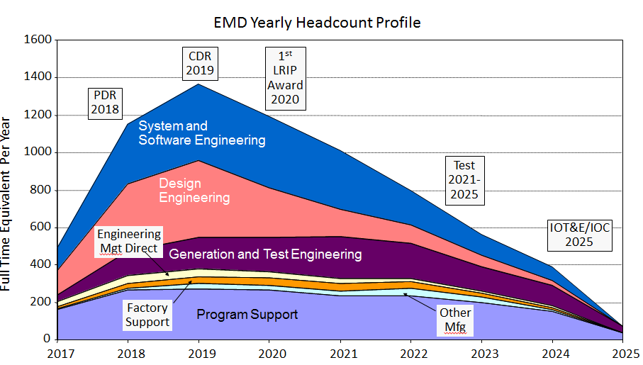

Source: Name Year if applicable. Classification: UNCLASSIFIED.

Figure 3.3‑2 Program Technical Staffing (mandatory) (sample)

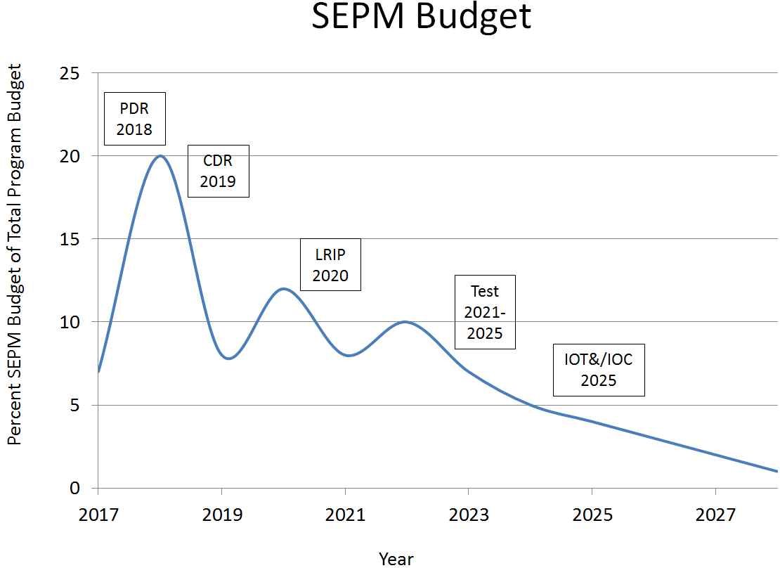

Source: Name Year if applicable. Classification: UNCLASSIFIED.

Figure 3.3‑3 SEPM Budget (mandatory) (sample)

### Engineering Team Organization and Staffing

* **Integrated Product Team (IPT) Organization** – Provide diagrams that show the government and contractor (when available) IPTs and their associated Working-level IPTs (WIPTs) and Working Groups interrelated vertically and horizontally and that illustrate the hierarchy and relationship among them (see Figure 3.3-4). Identify the government leadership for all teams.
* **IPT Details** – For government and contractor(s) (when available) IPTs and other key teams (e.g., Level 1 and 2 IPTS and WGs), include the following details either by attaching approved charters or in a table (see Table 3.3‑1):
* IPT name
* Functional team membership (to include external program members and all design consideration areas from )
* IPT roles, responsibilities, and authorities
* IPT products (e.g., updated baselines, risks, etc.)
* IPT-specific TPMs and other metrics.

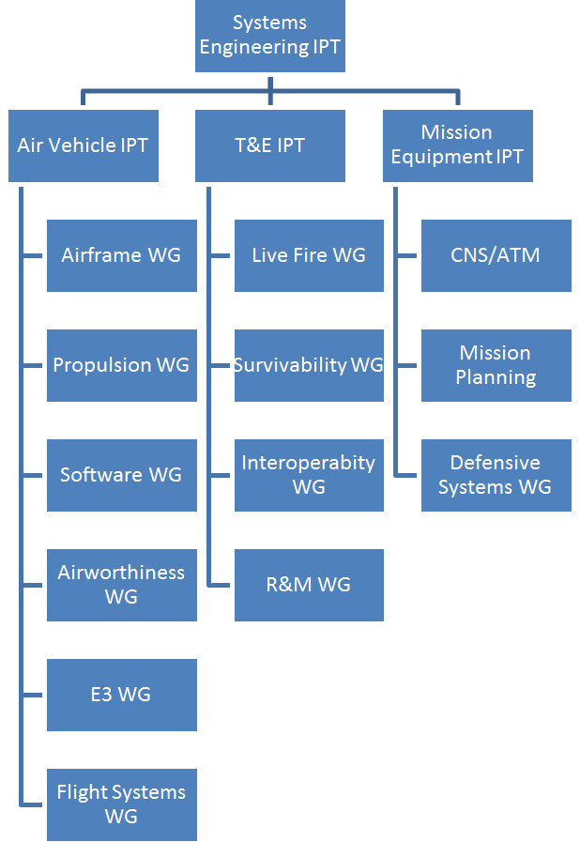

Source: Name Year if applicable. Classification: UNCLASSIFIED.

Figure 3.3‑4 IPT/WG Hierarchy (mandatory) (sample)

#### Expectation: Programs should integrate SE activities with all appropriate functional and stakeholder organizations. In addition, IPTs should include personnel responsible for each of the design consideration areas in Table 4.4‑1 (page 35). Note: Ensure that the IPTs in Figure 3.3-4 (above) match the IPTs in Table 3.3‑1 (next page).

Table 3.3‑1 Integrated Product Team Details (mandatory unless charters are submitted) (sample)

| Team  Name | Chair | Team Membership  (by Function or Organization) | Team Role, Responsibility, and Authority | Products and Metrics |
| --- | --- | --- | --- | --- |
| SE IPT | Lead SE | * Program Office   + Platform Lead   + Mission Equipment Lead   + Weapons Lead   + Test Manager   + Logistics Manager   + SW Lead   + Production/Quality Manager   + Safety Lead   + Interoperability Representative   + R&M Lead   + System Security Engineering Lead * PEO and Program Manager * Service Representative * OSD SE * Key Subcontractor or Suppliers * External programs | Role: IPT Purpose (e.g. Aircraft Design and Development)  Responsibilities: Integrate all technical efforts (Example)   * Manage and oversee design activities * Oversee configuration management of requirements and their traceability * Manage Specialty Engineering activities including the following disciplines: survivability/vulnerability, human systems/factors, ‘Electromagnetic Environmental Effects (E3), Reliability and Maintainability (including Availability), System Security, and Environmental Impacts to System/Subsystem Performance * Manage Safety and Certification requirements * Ensure compliance with applicable International, Federal, State, and local ESOH laws, regulations, and treaties * Manage system manufacturing assessments, weight, and facilities management (System Integration Laboratory) planning * Perform functional allocations and translate the system definition into WBS * Ensure compliance with all Specialty Engineering specification requirements * Manage SEIT performance through EVMS, TPMs, and other metrics and risk assessments * Identify and communicate SEIT issues to leadership * Evaluate technical and performance content and cost/schedule impacts to support the CCB process * Support test plan development and execution * Support the T&E IPT in system verification requirements * Support the Product Support IPT Working Groups and other TIMs * Develop and support the SEIT part of the incremental development and technology refresh processes * Support PMRs * Support program technical reviews and audits Perform SEIT trade studies to support affordability goals/caps   Schedule and frequency of meetings  Date of signed IPT charter and signatory | Products:  SEP/SEP Updates  WBS, IMP/IMS Input  Specifications  Metrics tracked by IPT:   * Cost * Performance * Schedule |
| XXX IPT | XXX Lead | * Program Office   + Lead SE   + Mission Equipment Lead   + Weapons Lead   + Test Manager   + Logistics Manager   + SW Lead   + R&M Lead   + Production/Quality Manager   + Safety Lead   + System Security Lead   + Interoperability Rep. * Key Subcontractor or Suppliers | Role: IPT Purpose  Responsibilities: Integrate all technical efforts   * Team Member Responsibilities * Cost, Performance, Schedule Goals * Scope, Boundaries of IPT Responsibilities   Schedule and frequency of meetings  Date of signed IPT charter and signatory | Products:   * Specification input * SEP input * TEMP input * AS input   Metrics tracked by IPT:   * Technical Performance Measure (TPM) 1 * TPM 2 |

## Technical Performance Measures and Metrics

Summarize the program’s strategy for selecting the set of measures for tracking and reporting the maturation of system development, design, and production. As the system matures, the program should add, update, or delete TPMs documented in the SEP.

(See DAG CH 3–4.1.3, Technical Assessment Process, for category definitions and additional guidance: <https://shortcut.dau.mil/dag/CH03.04.01.03>.) This section should include:

* An overview of the measurement planning and selection process, including the approach to monitor execution to the established plan, and identification of roles, responsibilities, and authorities for this process
* A set of TPMs covering a broad range of 15 core categories, rationale for tracking, intermediate goals, and the plan to achieve them with as-of dates (to provide quantitative insight into requirements stability and specification compliance). (See examples in Table 3.4-1)
* How the program documents adding or deleting any TPMs and changes of any TPM goals
* Whether there are any contractual provisions related to meeting TPM goals or objectives
* Description of the traceability between Key Performance Parameters (KPPs), Key System Attributes (KSAs), key technical risks and identified TPMs, Critical Technical Parameters (CTPs) listed in the TEMP or other measures:
* Identify how the achievement of each CTP is covered by a TPM. If not, explain why a CTP is not covered by a TPM.
* Identify planned manufacturing measures, appropriate to the program phase, to track manufacturing readiness performance to plan.
* Identify SW measures for SW technical performance, process, progress, and quality.
* If JMT analysis was completed to support material development, a description of the mapping between interoperability/interface specifications and the JMT
* How SEP TPMs are verified.

Table 3.4-1 provides examples of TPMs in each of 15 core categories. The table includes examples of each, with intermediate goals, a best practice for effective technical management.

Table 3.4‑1 Technical Performance Measures and Metrics (mandatory) (sample)

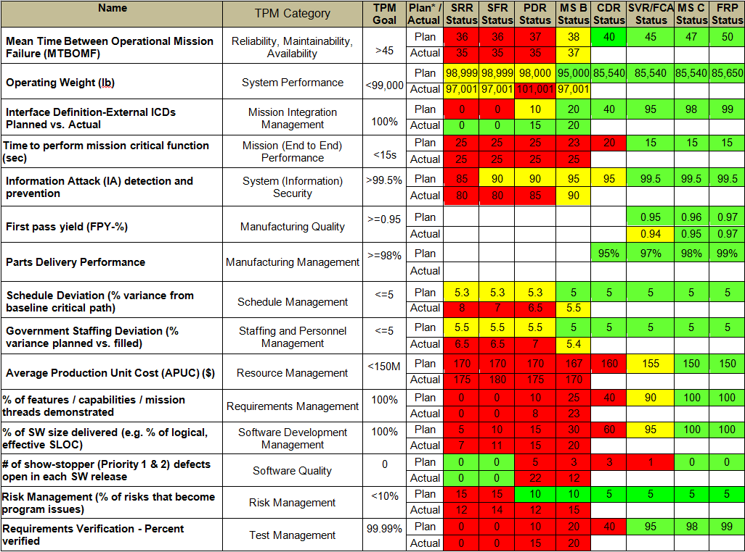

Source: Name Year if applicable. Classification: UNCLASSIFIED.

#### Expectation: Program uses metrics to measure and report progress. These measures form the basis to assess readiness for Milestone decisions, IMP criteria, and contract incentives and actions. The metrics and measures are relevant to the current program phase and specifically the end of phase decision(s) to be made.

Figure 3.4-1 depicts the characteristics of a properly defined and monitored TPM to provide early detection or prediction of problems that require management.



Source: Name Year if applicable. Classification: UNCLASSIFIED.

Figure 3.4‑1 Technical Performance Measure or Metric Graph (recommended) (sample)

Figure 3.4-2 depicts the relationship among Contingency, Current Best Estimate, Worst Case Estimate, Threshold, and Margin, as well as example criteria for how contingency changes as the system/testing matures.



Source: Name Year if applicable. Classification: UNCLASSIFIED.

Figure 3.4‑2 TPM Contingency Definitions

* **Reliability Growth Curves** (RGCs) **–** The System RGC(s) is (are) mandatory TPMs (DoDI 5000.02 (Change 2, Feb 2, 2017), Enclosure 3, para. 12.c.). Instances of reliability, availability, and maintainability (RAM) metric entries in Table 3.4-1 (Technical Performance Measures and Metrics) represent selected important metrics contributing to the system RGC(s).
* For reliability, Program Managers will use an RGC to plan, illustrate, and report progress. The growth curves are stated in a series of intermediate goals and tracked through fully integrated, system-level test and evaluation events until the reliability threshold is achieved. Figure 3.4-3 shows a sample RGC.
* If a single curve is not adequate to describe overall system reliability, provide curves for critical subsystems with rationale for their selection.
* Quantitatively detail how SW is accounted for in total system reliability. If not, describe why not and how the program plans to identify, measure, analyze, and manage the impact of SW on system reliability.

*Note:* For ACAT I programs, performance-to-plan is checked during Program Support Assessments (PSAs) and other engagements.

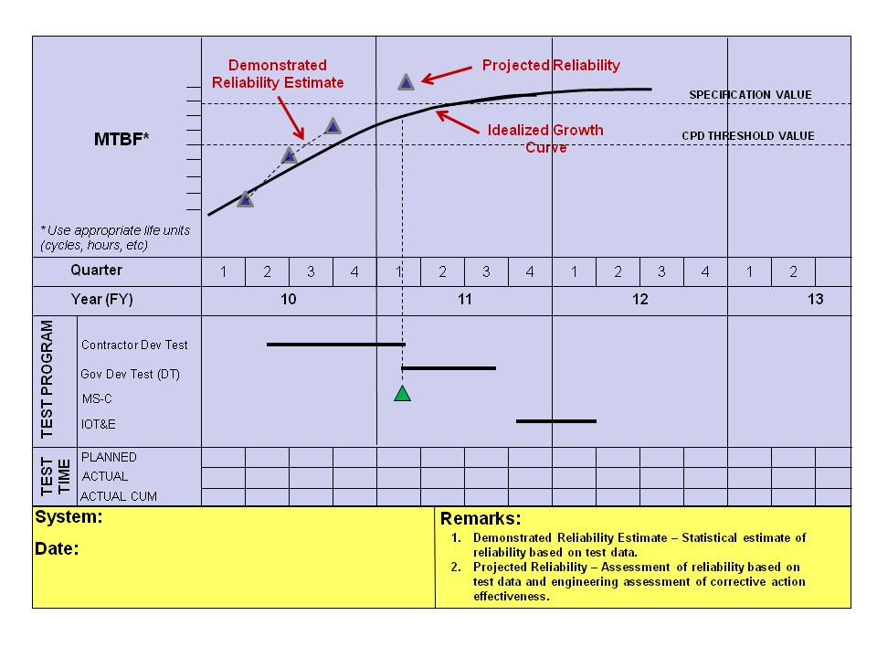

Source: Name Year if applicable. Classification: UNCLASSIFIED.

Figure 3.4‑3 Reliability Growth Curve (mandatory) (sample)

#### Expectation: Program should determine testing, test schedule, and resources required to achieve the specification requirement. Program should consider the following:

* + - * Provide a reliability growth curve for each reliability threshold.
      * Develop the reliability growth curve as a function of appropriate life units (hours, cycles, etc.) to grow to the specification value.
      * State how the program determined the starting point that represents the initial value of reliability for the system.
      * State how the program determined the rate of growth.
        + Rigorous test programs that foster the discovery of failures, together with management-supported analysis and timely corrective action, usually result in a faster growth rate.
        + The rate of growth should be tied to realistic management metrics governing the fraction of initial failure rate to be addressed by corrective actions along with the effectiveness of the corrective action.
      * Describe the growth tracking and projection methodology used to monitor reliability growth during system-level test (e.g., AMSAA-Crowe Extended, AMPM).

# Technical Activities and Products

## Planned SE Activities for the Next Phase

Summarize key planned systems engineering, integration, and verification activities for the next acquisition phase, including updated risk reduction and mitigation strategies and technical and manufacturing maturity.

* List all technology insertion and refresh projects, approved or tentative, and describe briefly:
* Planning/execution status (e.g., nascent, drawings 50% complete)
* Rationale (e.g., late developing technology enables cost-effective achievement of user objective requirement(s), response to upgraded adversary capabilities, cost-effective improvement in R&M)
* Whether project is covered in current acquisition program baseline. If not, state plan to fund project
* Any special (that would not otherwise be included) provisions in the present system design that enable/facilitate the project
* All identified related risks with status of mitigation plans; list with links suffices
* For emerging technology, which IPT(s) is (are) responsible for tracking and evaluation; include present maturity status
* If the technology is newly matured, the nature of the demonstration or provide links to test/demonstration reports.
* For the Milestone A SEP, summarize the early systems engineering analysis and assessment results that show how the proposed materiel solution is technically feasible and has the ability to effectively address capability gaps, desired operational attributes, and associated external dependencies.
  + Summarize the technical assessment of the SW, integration, manufacturing, and reliability risks. Describe how trade-off analysis input ensures the system requirements (including KPPs and KSAs) are achievable within cost and schedule constraints.
  + For MDAPs, document the trades between reliability, downtime (includes maintainability), Operational Availability, and Operations and Support cost in the Reliability, Availability, Maintainability, and Cost (RAM-C) Rationale Report.
* For the Development RFP Release Decision Point/Milestone B SEP, discuss how prototyping will ensure requirements will be met within cost and schedule constraints.
* Technical Review Planning – Summarize the PMO’s plans for conducting each future technical review. The Lead Systems Engineer should be responsible for the overall conduct of technical reviews.
  + If useful, add a diagram of the process with the objective timeframes for each activity before, during, and after the technical review.
  + Technical reviews should be conducted when the system under review is sufficiently mature and ready to proceed to the next phase.
  + Entrance criteria should include maturity metrics, such as percentage of drawings released, percentage of interfaces defined, etc.
* For each planned system-level technical review in the next acquisition phase, provide a technical review table (see Table 4.1-1). This table, or something analogous, is mandatory. (See DAG CH 3–3.3, Technical Reviews and Audits Overview, for additional guidance: <https://shortcut.dau.mil/dag/CH03.03.03>.)

#### Expectation: Program should use a standard process for conducting technical reviews. If a SETR guide and charter are available, then reference and provide.

Table 4.1‑1 Technical Review Details (mandatory) (sample)

|  |  |
| --- | --- |
| XXX Details Area | XXX Review Details  *(Fill out tailored criteria for this acquisition phase, etc.)* |
| Chairperson | Identify the Technical Review Chair |
| PMO Participants | Identify Positions/functions/IPTs within the program offices which are anticipated to participate(Engineering Leads; Risk, Logistics, and Configuration Managers, DCMA Rep., and Contracting Officer, etc.). |
| Anticipated Stakeholder Participant Organizations | Identify representatives (stakeholders) from Service SE and Test, DASD(SE), external programs, the User, and participants with sufficient objectivity with respect to satisfying the preestablished review criteria. |
| Purpose (of the review) | Describe the main purpose of the review and any specific SE goals. |
| Entrance Criteria | Identify tailored Entrance Criteria established for conducting an event-driven review. (Criteria should be objective and measurable/observable.) |
| Exit Criteria | Identify tailored Exit Criteria. (Criteria should be objective and measurable/observable.) |
| Products/Artifacts (from the review) | List expected products from the Technical Review (for example):   * Established system allocated baseline * Updated risk assessment for EMD * What artifacts constitute the baseline * Assessment of SW development progress * Updated Cost Analysis Requirements Document (CARD) or CARD-like document based on system allocated baseline * Updated program schedule including system and SW critical path drivers * Approved Life-Cycle Sustainment Plan (LCSP) updating program sustainment development efforts and schedules. |

#### Expectation: Program plans and conducts event-driven technical reviews.

## Requirements Development and Change Process

* **Analysis and Decomposition** – Describe how requirements are traced, managed, and tracked from the source JCIDS documents down to configuration item (CI) build-to specifications and verification plans. (See DAG section CH 3–4.2.2 Requirements Analysis Process for additional guidance: <https://shortcut.dau.mil/dag/CH03.04.02.02>.)
* Describe how the JCIDS reliability and maintainability (R&M) thresholds were translated into contract specification requirements, ensuring they are consistent with those in the Acquisition Strategy.

#### Expectation: Program should trace all requirements from JCIDS (or equivalent requirements document) into a verification matrix, equivalent document, or software tool. The system Requirements Traceability Matrix (RTM) should be embedded in the SEP, or a link provided, or a copy provided as an appendix. Table 4.2-1 shows a sample RTM. Figure 4.2 1 shows a sample Requirements Decomposition/Specification Tree.

Table 4.2‑1 Requirements Traceability Matrix (mandatory) (sample)

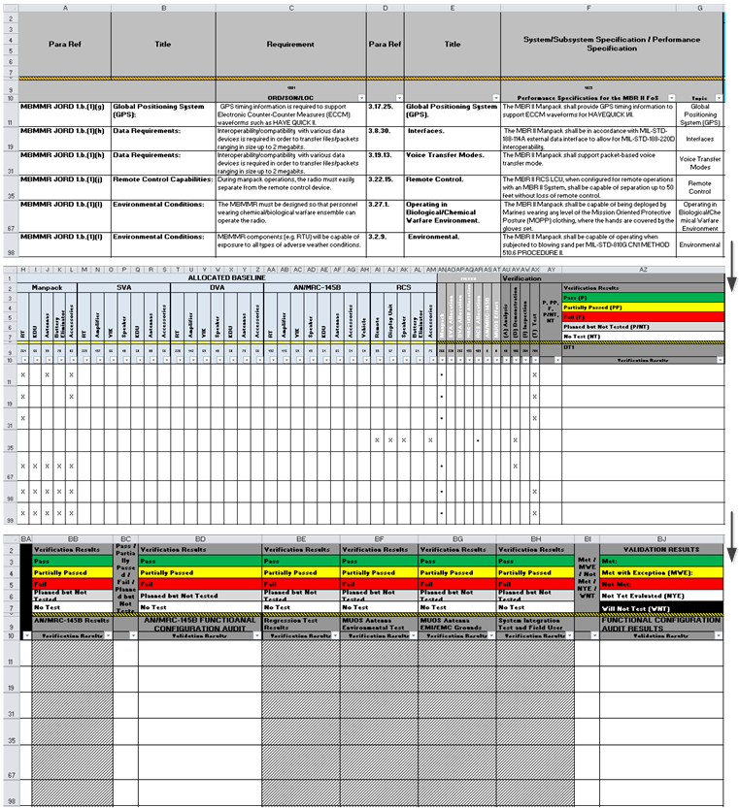

Source: Name Year if applicable. Classification: UNCLASSIFIED.

(See example here: )

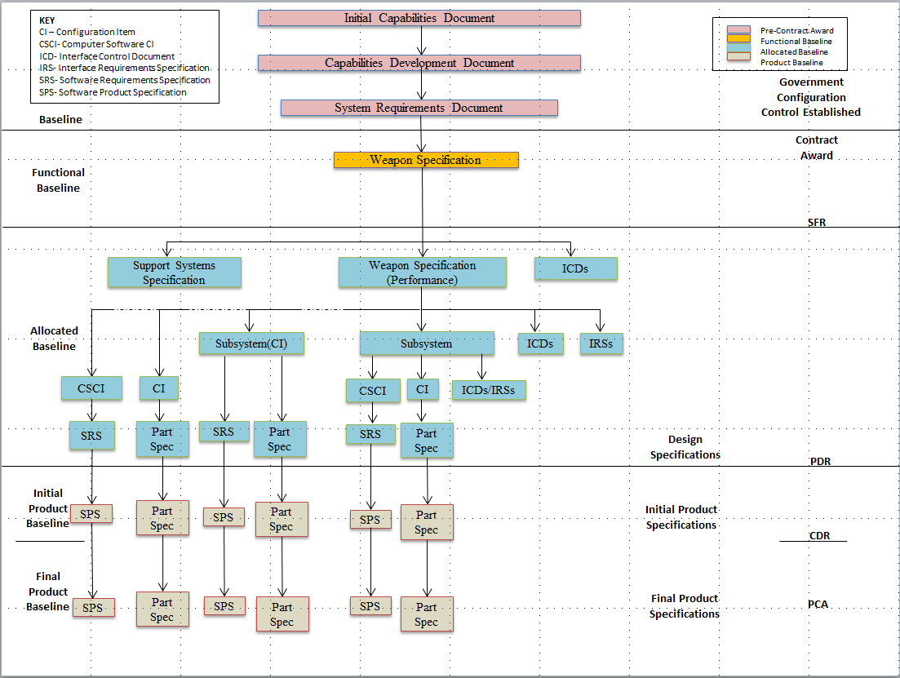

Source: Name Year if applicable. Classification: UNCLASSIFIED.

Figure 4.2‑1 Requirements Decomposition/Specification Tree/Baselines (mandatory) (sample)

## Configuration and Change Management

* If a configuration management plan is available, then provide link. Otherwise, provide the following:
* **Technical Baseline Artifacts** – List and describe baseline artifacts. At a minimum, describe the artifacts of the functional, allocated, and product baselines and when each technical baseline is established and verified. (See DAG CH 3–4.1.6, Configuration Management Process, for additional guidance: <https://shortcut.dau.mil/dag/CH03.04.01.06>.)
* SFR = Functional Baseline = Artifacts containing the system’s performance (functional, interoperability, and interface characteristics) and the verification required to demonstrate the achievement of those specified characteristics.
* PDR = Allocated Baseline = Artifacts containing the functional and interface characteristics for all system elements (allocated and derived from the higher-level product structure hierarchy) and the verification required to demonstrate achievement of those specified characteristics.
* CDR = initial Product Baseline = Artifacts containing necessary physical (form, fit, and function) characteristics and selected functional characteristics designated for production acceptance testing and production test requirements, including “build-to” specifications for HW (product, process, material specifications, engineering drawings, and other related data) and SW (SW module design – “code-to” specifications).

#### Expectation: Program should understand which artifacts make up each technical baseline and manage changes appropriately. At completion of the system-level CDR, the Program Manager will assume control of the initial product baseline, to the extent that the competitive environment permits (DoDI 5000.02, Enclosure 3, para. 8, page 84).

* **Configuration Management/Control (and Change) Process Description** – Provide a process diagram (see Figure 4.3-1), of how the program maintains configuration control of its baselines. Describe the approach the program office takes to identify, document, audit, and control the functional and physical characteristics of the system design; track any changes; and provide an audit trail of program design decisions and design modifications.

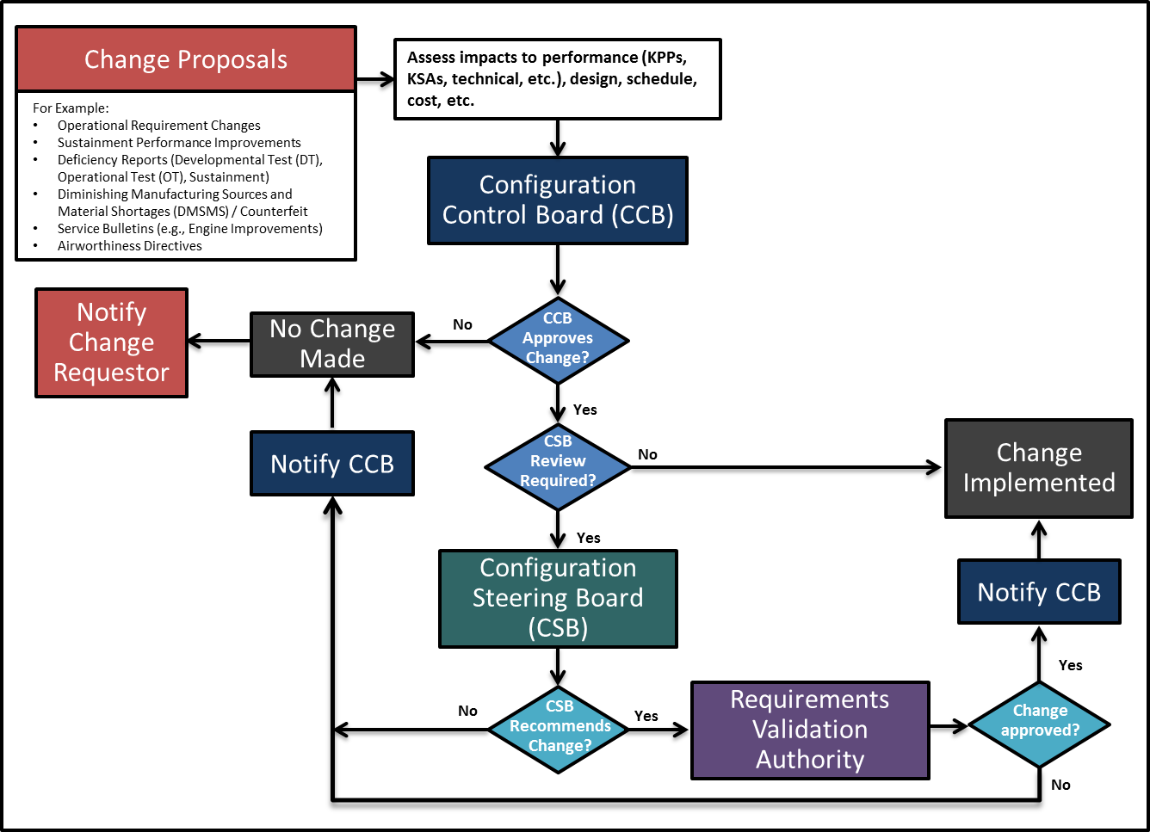

Source: Name Year if applicable. Classification: UNCLASSIFIED.

Figure 4.3‑1 Configuration Management Process (mandatory) (sample)

* **Roles, Responsibilities, and Authorities** – Summarize the roles, responsibilities, and authorities within the CM process. If this includes one or more configuration boards, describe the hierarchy of these boards, their frequency, who (by position) chairs them, who participates, and who (by position) has final authority in each. Identify who has configuration control and when.
* **Configuration Change Process** – Outline the process the program uses to change the technical baseline/configuration and specifically address:
  + - How changes to a technical baseline are identified, evaluated, approved/disapproved, recorded, incorporated, and verified
    - How product information is captured, maintained, and traced back to requirements
    - How requirements for in-service configuration/design changes are determined and managed/controlled
    - How internal and external interfaces are managed and controlled
    - The process by which the program and external programs review configuration changes for possible impacts on each other’s programs
    - How the Intellectual Property Strategy affects and influences the planned configuration control processes.
* **Classification of Changes –** Define the classification of changes (Class 1, Class 2, etc.) applicable to the program and approval authority. Identify by position who in the CM process is responsible for determining the classification of a change and who (by position) verifies/confirms/approves it.

#### Expectation: Program controls the baselines.

## Design Considerations

See DAG CH 3–4.3, Design Considerations (<https://shortcut.dau.mil/dag/CH03.04.03>), for a partial list of design considerations. Not all are equally relevant or critical to a given program, but all should be examined for relevancy. In the mandatory table (see Table 4.4-1), identify the key design considerations that are critical to achieving the program’s technical requirements. If additional documentation is required, those documents may need to be embedded in the SEP or hot linked. (See DoDI 5000.02 (Change 2, Feb 2, 2017), Enclosure 1, Table 2: <http://www.dtic.mil/whs/directives/corres/pdf/500002_dodi_2015.pdf>.)

#### Expectation: SEP outlines the design considerations.

Table 4.4‑1 Design Considerations (mandatory) (sample)

| Mapping Key Design Considerations into Contracts | | | | | |
| --- | --- | --- | --- | --- | --- |
| Name (Reference) | Cognizant  PMO  Org | Certification | Documentation  (hot link) | Contractual Requirements  (CDRL #) | Description/Comments |
| Chemical, Biological, Radiological, and Nuclear (CBRN) Survivability |  |  |  |  | Describe how design incorporates the CBRN survivability requirements and how progress toward these requirements is tracked and documented over the acquisition life cycle. For additional information on CBRN Survivability, see <https://www.dodtechipedia.mil/dodwiki/display/techipedia/Chemical%2C+Biological%2C+Radiological%2C+and+Nuclear+Survivability> ([Defense Technical Information Center](http://www.dtic.mil/dtic/) (DTIC) Account Required). |
| Manufacturing and Producibility |  |  | Manufacturing Plan (optional plan) |  | Describe how manufacturing readiness and risk are assessed for the next acquisition phase. During Technology Maturation and Risk Reduction Phase, describe how manufacturing processes are assessed and demonstrated to the extent needed to verify that risk has been reduced to an acceptable level. During the Engineering and Manufacturing Development Phase, describe how the maturity of critical manufacturing processes are assessed to ensure they are affordable and executable. Before a production decision, describe how the program ensures manufacturing and producibility risks are acceptable, supplier qualifications are completed, and any applicable manufacturing processes are under statistical process control. |
| Modular Open Systems Approach |  |  |  |  | Describe how a modular open systems approach (MOSA) used in the system’s design to enable affordable change, evolutionary acquisition, and interoperability. Provide rationale if it is not feasible or cost-effective to apply MOSA. |
| System Security Engineering |  |  |  |  | Describe how the design addresses protection of DoD warfighting capability from foreign intelligence collection; from hardware, software vulnerabilities, cyberattacks, and supply chain exploitation; and from battlefield loss throughout the system life cycle, balancing security requirements, designs, testing, and risk management in the respective trade spaces. (See Table 4.4-2.) |
| Reliability and Maintainability3 |  |  | R&M contract language1  The SEP shall attach or link to the RAM-C Report2  (MS A, Dev RFP Rel, B, & C) |  | Describe how the program implements and contracts for a comprehensive R&M engineering program to include the phased activities in Table 4.4-3 and how R&M is integrated with SE processes. |
| Intelligence (Life-Cycle Mission Data Plan) |  |  | LMDP  (MS A, Dev RFP Rel, B, & C)  (If intelligence mission data dependent) |  | Summarize the program’s plans to identify Intelligence Mission Data (IMD) requirements and IMD need dates. Summarize the plans to assess IMD risks and develop IMD (only required if dependent on IMD). |

*Note* regarding Key Design Considerations table:

* **Name** – See DAG CH 3–4.3, Design Considerations, for a more comprehensive listing of design considerations: [https:/shortcut.dau.mil/dag/CH03.04.03](https://shortcut.dau.mil/dag/CH03.04.03).
* **Cognizant PMO Organization** – List assigned IPT/WIPT/WG for oversight.
* **Certification** – List as appropriate, to include Technical Authority and timeframe.
* **Documentation** – List appropriate PMO and/or contractor documents and hot link.
* **Contractual Requirements** – List contract clauses the PMO is using to address the topic.
* **Description/Comments** – Include as needed, to inform other PMO members and stakeholders.
* 1 Relevant R&M sections of the Systems Specification, SOW, Statement of Objectives (SOO), and Sections L and M
* 2 DoDI 5000.02 (Change 2, Feb 2, 2017), Enclosure 3, para 12.b, [(http://www.dtic.mil/whs/directives/corres/pdf/500002_dodi_2015.pdf)](http://www.dtic.mil/whs/directives/corres/pdf/500002_dodi_2015.pdf) DoD RAM-C Report Manual, June 1, 2009 (<http://www.acq.osd.mil/se/docs/DoD-RAM-C-Manual.pdf>).
* 3 Space programs should address Mission Assurance (MA) planning in the context of reliability and provide a description of MA activities undertaken to ensure that the system operates properly once launched into orbit. Specifically, space programs should describe how the MA process employed meets the best practices described in the Mission Assurance Guide (see Aerospace Corporation TOR-2007(8546)-6018 REV. B, section 10.6.3 [(http://aerospace.wpengine.netdna-cdn.com/wp-content/uploads/2015/05/Mission-Assurance-Guide-TOR-20078546-6018-REV-B.pdf)](http://aerospace.wpengine.netdna-cdn.com/wp-content/uploads/2015/05/Mission-Assurance-Guide-TOR-20078546-6018-REV-B.pdf), Risk Management). This description should include program phase-dependent processes and planning for MA in the next phase of the program and the way program MA processes adhere to applicable policies and guidance. Also describe the launch and operations readiness process.

#### Expectation: Program Manager will employ system security engineering practices and prepare a Program Protection Plan (PPP) (DoDI 5000.02 (Change 2, Feb 2, 2017), Enclosure 3, para. 13.a., page 99) to guide the program’s efforts and the actions of others to manage the risks to critical program information (CPI), mission-critical functions, and critical components associated with the program. Table 4.4-2 summarizes the protection scheme/plan for the program’s CPI and critical components.

#### Expectation: Program should understand that the content of the R&M artifacts needs to be consistent with the level of design knowledge that makes up each technical baseline. (See DAG CH 3–4.3.19, Reliability and Maintainability Engineering, for R&M guidance by acquisition phase: <https://shortcut.dau.mil/dag/CH03.04.03.19>.) Table 4.4-3 provides an example of R&M activity planning.

Table 4.4‑2 CPI and Critical Components Countermeasure Summary (mandatory) (sample)

|  |  |  |  |  |  |  |  |  |  |  |  |  |  |  |  |  |  |  |  |  |
| --- | --- | --- | --- | --- | --- | --- | --- | --- | --- | --- | --- | --- | --- | --- | --- | --- | --- | --- | --- | --- |
|  | # | Protected Item  (Inherited and Organic) | | Countermeasures | | | | | | | | | | | | | | | | |
| 1 | 2 | 3 | | 4 | 5 | 6 | 7 | 8 | 9 | 10 | 11 | 12 | 13 | 14 | 15 | 16 |
| CPI | 1 | Algorithm QP | | X | X | X | | X | X | X | X |  | X |  |  |  |  | X | X |  |
| 2 | System Security Configuration | |  |  |  | |  |  |  |  |  |  |  | X |  |  | I |  |  |
| 3 | Encryption Hardware | | X | X | X | | X | X | X | X | X |  |  |  | X |  | X |  |  |
| 4 | IDS Policy Configuration | | X | X | X | | X | X | X | X | X |  |  |  |  |  | X |  |  |
| 5 | IDS Collected Data | | X | X | X | | X | X | X | I |  |  |  |  |  |  |  | I |  |
| 6 | KGV-136B | | X | X | X | | X |  |  | I |  | I |  |  |  | I |  |  |  |
| Critical Components | 7 | iDirect M1D1T Hub-Line Card | | X | X | X | | X | X | X | X | X |  |  |  | X | X | X |  |  |
| 8 | Cisco Router IOS with ASO | | X | X | X | | X | X | X |  |  |  |  |  |  |  | X |  |  |
| 9 |  | |  |  |  | |  |  |  |  |  |  |  |  |  |  |  |  |  |
| 10 |  | |  |  |  | |  |  |  |  |  |  |  |  |  |  |  |  |  |
| 11 |  | |  |  |  | |  |  |  |  |  |  |  |  |  |  |  |  |  |
| 12 |  | |  |  |  | |  |  |  |  |  |  |  |  |  |  |  |  |  |
| 13 |  | |  |  |  | |  |  |  |  |  |  |  |  |  |  |  |  |  |
|  |  | KEY [Examples Included: UPDATE THIS LIST ACCORDING TO PROGRAM] | | | | | | | | | | | | | | | | | | |
|  |  | | General CMs | | | | Research and Technology Protection CMS | | | | | | | | | Trusted  System Design CMs | | | | |
|  | **Key**  X = Implemented  I = Denotes protection already implemented if CPI is inherited | | **1** Personnel Security  **2** Physical Security  **3** Operations Security  **4** Industrial Security  **5** Training  **6** Information Security  **7** Foreign Disclosure/ Agreement | | | | **8** Transportation Mgmt  **9** Anti-Tamper  **10** Dial-down Functionality | | | | | | | | | **11** IA**/**Network Security  **12** Communication Security  **13** Software Assurance  **14** Supply Chain Risk Management  **15** System Security Engineering  **16** Other | | | | |

Table 4.4‑3 R&M Activity Planning and Timing (mandatory) (sample)

|  |  |
| --- | --- |
| R&M Engineering Activity | Planning and Timing |
| R&M Allocations |  |
| R&M Block Diagrams |  |
| R&M Predictions |  |
| Failure Definition and Scoring Criteria |  |
| Failure Mode, Effects, and Criticality Analysis (FMECA) |  |
| Maintainability and Built-In Test Demonstrations |  |
| Reliability Growth Testing at the System and Subsystem Level |  |
| Failure Reporting, Analysis, and Corrective Action System (FRACAS) |  |
| Etc. |  |

*Note* regarding R&M Activity Planning table:

* **R&M Allocations** – R&M requirements assigned to individual items to attain desired system-level performance. Preliminary allocations are expected by SFR with final allocations completed by PDR.
* **R&M Block Diagrams** – The R&M block diagrams and math models prepared to reflect the equipment/system configuration. Preliminary block diagrams are expected by SFR with the final completed by PDR.
* **R&M Predictions** – The R&M predictions provide an evaluation of the proposed design or for comparison of alternative designs. Preliminary predictions are expected by PDR with the final by CDR.
* **Failure Definition and Scoring Criteria** – Failure definitions and scoring criteria to make assessments of R&M contract requirements.
* **FMECA** – Analyses performed to assess the severity of the effects of component/subsystem failures on performance. Preliminary analyses are expected by PDR with the final by CDR.
* **Maintainability and Built-In Test** – Assessment of the quantitative and qualitative maintainability and Built-In test characteristics of the design.
* **Reliability Growth Testing at the System and Subsystem Level** – System reliability growth testing and subsystem testing, e.g., accelerated or highly accelerated life testing (ALT/HALT), is implemented to identify failure modes, which if uncorrected could cause the equipment to exhibit unacceptable levels of reliability performance during operational use.
* **FRACAS** – Engineering activity during development, production, and sustainment to provide management visibility and control for R&M improvement of HW and associated SW by timely and disciplined utilization of failure data to generate and implement effective corrective actions to prevent failure recurrence.

##### Appendix A – Acronyms

*Provide a list of all acronyms used in the SEP.* Example List:

|  |  |
| --- | --- |
| FMECA | Failure Mode, Effects, and Criticality Analysis |
| FRACAS | Failure Reporting, Analysis, and Corrective Action System |
| JCIDS | Joint Capabilities Integration and Development System |
| SEP | Systems Engineering Plan |
| OUSD | Office of the Under Secretary of Defense |
|  |  |

##### Appendix B – Item Unique Identification Implementation Plan

*Attach a copy of the plan.*

##### References

*Note:* Include complete references to correspond with text citations. Include citations and references for illustrations reprinted from another source. Illustrations with no source information are assumed to be original to the SEP. Example List:

Chemical, Biological, Radiological, and Nuclear (CBRN) Survivability<https://www.dodtechipedia.mil/dodwiki/display/techipedia/Chemical%2C+Biological%2C+Radiological%2C+and+Nuclear+Survivability>.”

DCMA-EA PAM 200.1. Earned Value Management System (EVMS) Program Analysis Pamphlet (PAP). Fort Belvoir: Defense Contract Management Agency, October 2012.  
<http://www.dcma.mil/LinkClick.aspx?fileticket=0CBjAarXWZA%3d&portalid=31>

Defense Acquisition Guidebook (DAG). Fort Belvoir, VA: Defense Acquisition University.  
<https://www.dau.mil/tools/dag>

Department of Defense Instruction (DoDI) 5000.02. Operation of the Defense Acquisition System. Change 2. Washington, D.C.: Under Secretary of Defense for Acquisition, Technology, and Logistics, February 2, 2017.  
<http://www.dtic.mil/whs/directives/corres/pdf/500002_dodi_2015.pdf>

Mission Assurance Guide. TOR-2007(8546)-6018 REV. B, section 10.6.3 Risk Management. El Segundo, CA: Aerospace Corporation, June 1, 2012.  
<http://aerospace.wpengine.netdna-cdn.com/wp-content/uploads/2015/05/Mission-Assurance-Guide-TOR-20078546-6018-REV-B.pdf>

*[Optional – break to create back cover on even page]*

Program Name Systems Engineering Plan

Contact Info

Distribution Statement